DESIGN AGENCY

# **AIM**

REDESIGN THE CONTACT PAGE OF DESIGN AGENCY

# **PROCEDURE**

CHOOSE YOUR FAVOURITE DESIGN AGENCY

ONCE THE PAGE IS SELECTED,THINK OF REDESIGNING IT

TRY TO CHANGE THE THEME

CHANGE THE FONTS IN MORE VISIBILITY MANNER

REDESIGN IT,IN A MORE EFFICIENT WAY

## IMAGE

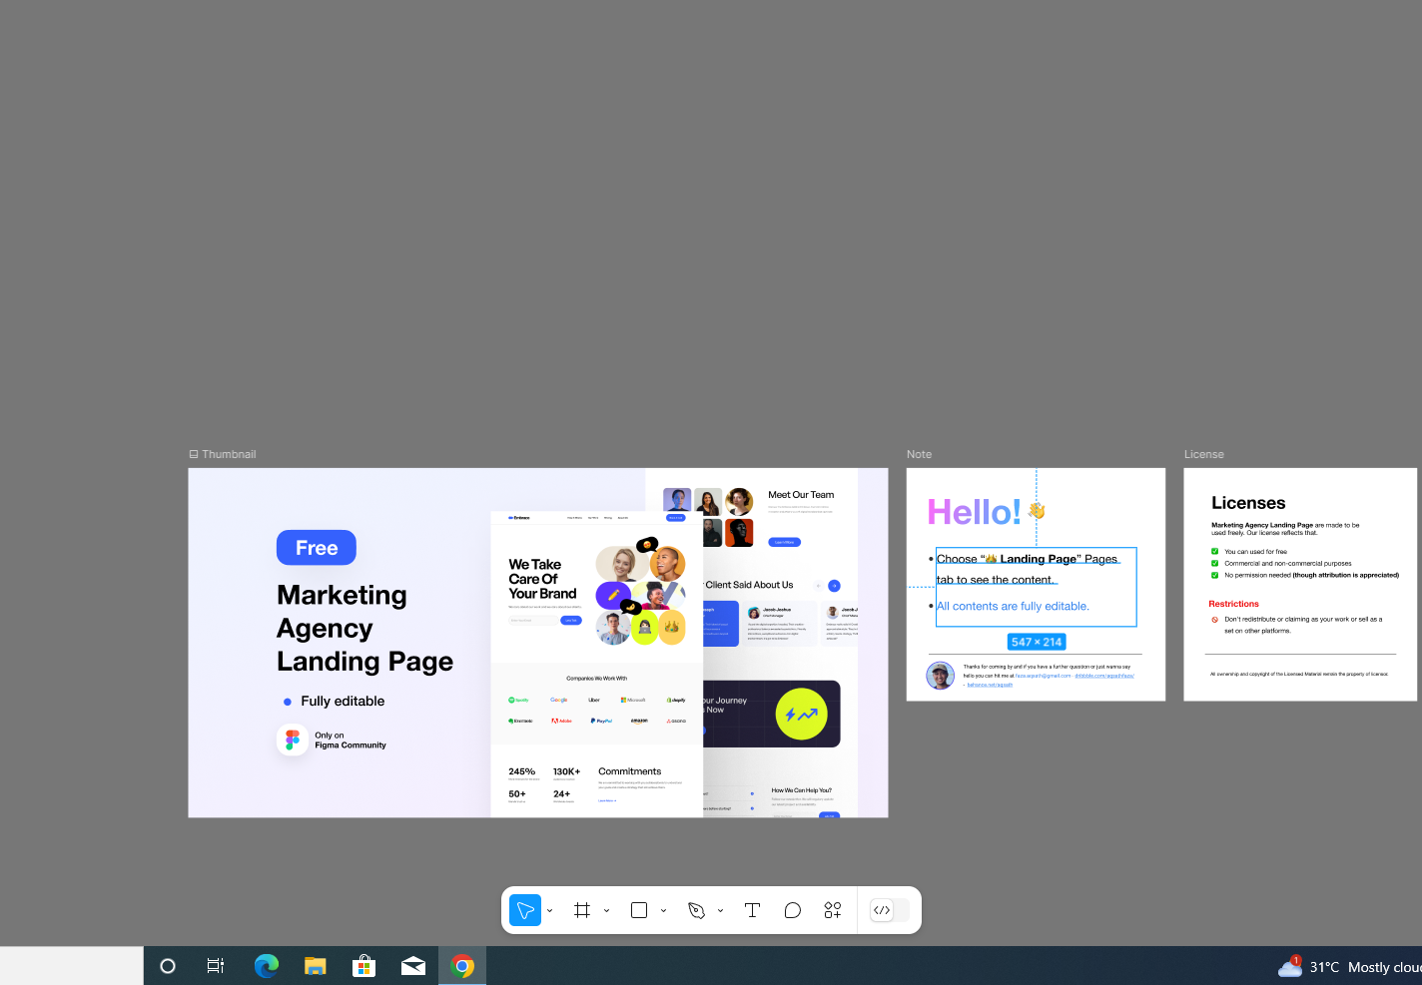

## RESULT

DESIGN AGENCY IS REDESIGNED